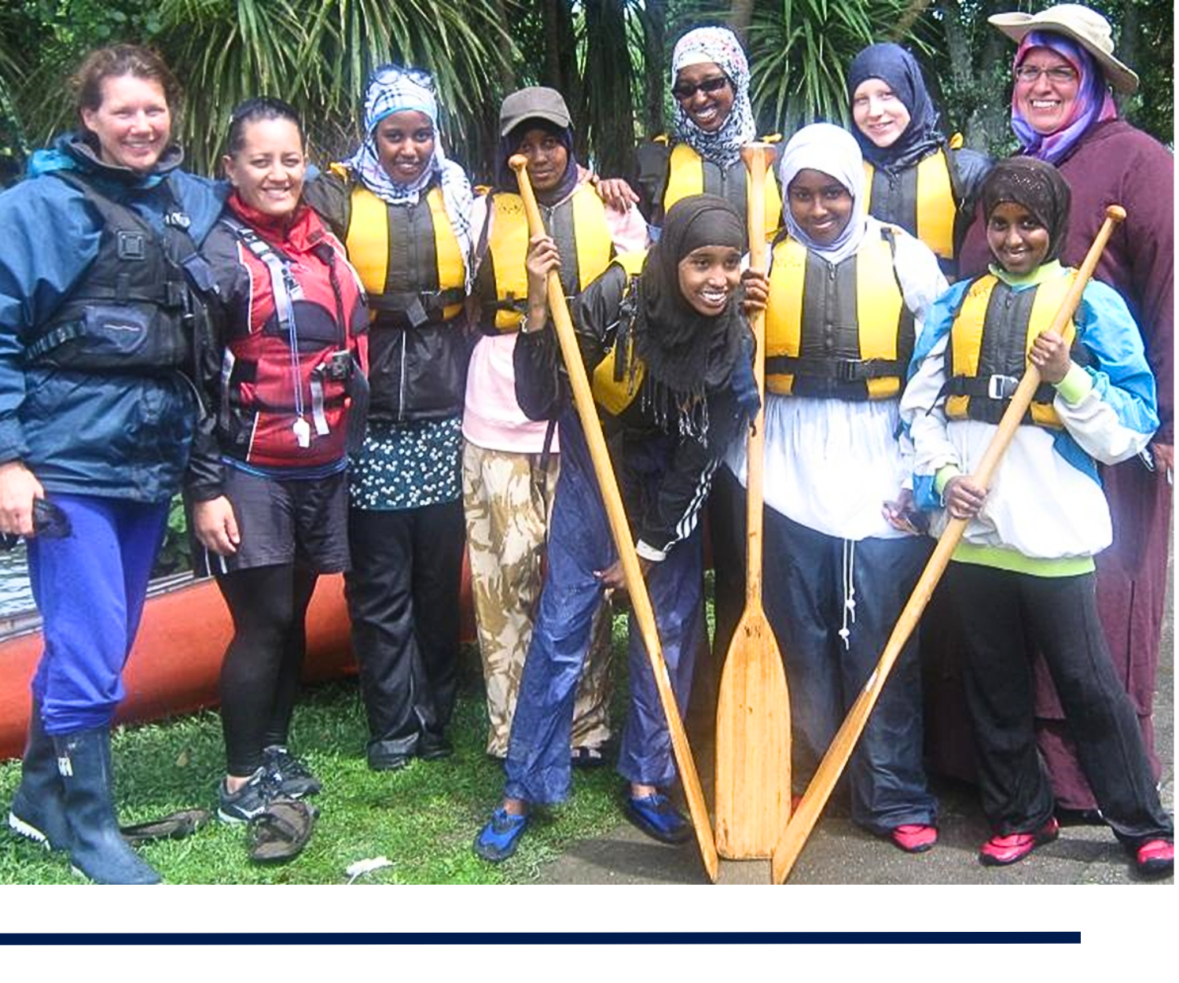

Increasing participation of Muslim women and girls

Good Practice Guide, Version 1
2025

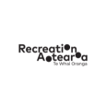

Introduction
This guide is intended to help improve the participation of Muslim women and girls (Muslimah) in outdoor activities. It describes strategies for outdoor centres, instructors, and leaders to improve religious and cultural sensitivity. It aims to create an inclusive environment that reduces or removes barriers to participation for Muslimah.

Why these guidelines were created
- To reduce the barriers to participation by Muslimah in outdoor activities, such as unintentional or unconscious bias, and address the potential for discriminatory behaviour.
- To increase cultural competency and awareness of outdoor operators and instructors in accommodating Muslimah in outdoor activities. To ensure Muslimah have their needs met.
- To reassure parents of Muslimah youth that religious and cultural accommodations can and are being made.
- To improve the physical and mental wellbeing of Muslimah while helping them to connect with the land where they live.
- To foster positive social interaction and collaboration among diverse groups.

Background
The Women's Organisation of the Waikato Muslim Association (WOWMA) has worked with First Step Outdoors (FSO) for over 15 years. WOWMA has created experiences that have led to successful and enthusiastic participation in outdoor activities. WOWMA has support from parents. Understanding of the value of the outdoors has increased in a core group within its community. WOWMA approached FSO to co-design and run leadership programmes for their female youth.
Other outdoor providers approached FSO seeking advice on how to remove barriers to participation for the Muslim community. They wanted to be better able, prepared, informed, and equipped to deliver inclusive, quality outdoor experiences to Muslimah youth.
It’s crucial to address the barriers that hinder engagement for Muslimah in outdoor programmes. Providers might not be aware of these barriers. This may lead to a perception that Muslimah women and girls choose not to participate. Actively removing barriers while accommodating specific needs creates an inclusive environment, where Muslimah women and girls feel enabled and encouraged to participate in outdoor activity programmes.

Who these guidelines are for
Good Practice Guidelines are intended to help leaders plan outdoor activities for diverse communities. Youth organisations, recreational clubs, schools, outdoor centres, commercial adventure operators, or any other relevant user can also use these guidelines.
“He waka eke noa.
A canoe, which we are all in with no exception.”

The value of inclusive outdoor activities

To encourage and enable participation, clearly communicate the value of Muslimah participating in outdoor activities can provide.

Explain to parents
It's important to communicate the value of participation in outdoor activities to Muslim parents, particularly those from migrant or refugee backgrounds. These parents may have experienced past trauma. They may feel unsafe letting their children participate in activities, which takes them out of their sight.
Highlighting the benefits of outdoor education may reassure them that their children will have opportunities for safe development. Such benefits include developing social skills, resilience, personal growth, fostering independence and a feeling of connection to the land where they're living.

Explain to participants
Clear explanations should be given on safety precautions and what participants can expect from activities. It’s important to acknowledge the inherent level of risk in outdoor activities. You should also emphasise the potential value and benefits outdoor activities offer. Seeing community members participating in, and benefitting from, outdoor activities can encourage Muslimah to join in. Endorsements from previous participants on their experience can serve as powerful testimonials, fostering a sense of trust and promote further participation within the Muslim community.

Explain to providers
Working to be inclusive of diversity is good for business. Providers will achieve great success by having fuller, richer participation by all. Accommodating the needs of Muslimah benefits outdoor education service providers. It fosters inclusivity, increases enrolment, enhances reputation, expands market reach, cultivates a safe environment, and promotes cultural understanding. The Muslim community has been an underserved market. It provides an opportunity for business growth while positively supporting the environment.

Outdoor activities can provide:
- A safe space to take part in a ‘Kiwi camp’ experience.
- An opportunity to connect to Aotearoa and its natural beauty by participating in outdoor adventures.
- A chance to explore new areas and experience new activities.
- Excitement, fun and a sense of mystery and adventure.
- Health benefits from physical activity in the outdoors.
- An opportunity to learn and practice new skills.
- Developing resilience in the face of challenges or adversity.
- An opportunity for social interaction while being part of a team working on a shared challenge.
Being outdoors has many benefits for Muslimah from their own religious perspective. The experience can allow them to slow down, connect with their creator while reflecting on his beauty and how things came to be. Muslim leaders from WOWMA have used the following verse (verse 15:19) from the Qur’an effectively to encourage reflections when in the outdoors:
“As for the earth, we spread it out and placed upon its firm mountains and caused everything to grow there in perfect balance”.

Cultural practice considerations

There are some specific cultural considerations for providers to bear in mind when planning outdoor activities for Muslimah.

Modest dressing
The Qur’an instructs both men and women to observe modesty in their dress and behaviour. However, Muslim women’s clothing isn’t entirely about adherence to faith. It has been used in the past – and present – as an assertion of identity.

Hijab
A Hijab is a head scarf / covering worn in public by some women and girls.
Wearing a Hijab can be a religious act. This is how they show their submission to God. It’s a symbolic way to pay respect and to identify with their religion. No one should be compelled to put a Hijab on or take it off. It’s crucial to understand that not all Muslimah decide to wear Hijab. Some wear it from a young age and others choose to wear it when they are elderly. (This depends on the individual and their understanding and interpretation of their faith and cultural norms).
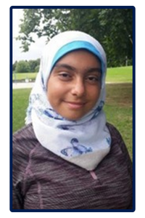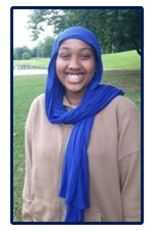
Figures 1 and 2: Pictures of Hijab being worn.
Source: First Step Outdoors.

Niqab
A Niqab is a veil for covering the hair and face except for the eyes that is worn by some Muslim women.
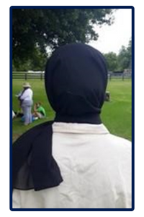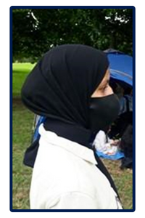
Figures 3 and 4: Picture of Niqab being worn from side profile and back.
Source: First Step Outdoors.

Abaya
The Abaya covers the whole body except the head, feet and hands. It can be worn with the Niqab or Hijab.
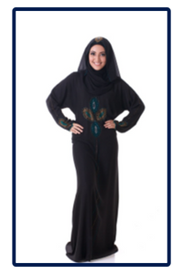
Figure 5: Picture of Abaya being worn with a Hijab.
Source: Stock images.

Burqa
The Burqa is a long loose garment covering the body from head to toe.
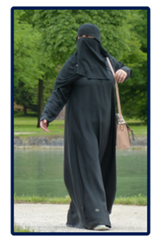
Figure 6: Picture of Burqa being worn.
Source: Stock images.

Salah / prayer
Muslims pray five times a day. The five prayers are: Fajr (dawn), Dhuhr (afternoon), Asr (after midday), Maghrib (after sunset) and Isha (night-time).
Before an event, organisers can either ask participants what time prayers are, or check Federation of Islamic Associations of New Zealand (FIANZ) prayer time. To use this site, select the city you’re in from the drop-down menu to display prayer times.
According to the Qur’an, participants who have travelled can shorten their prayers. It allows for the combination of the afternoon and midday prayer, as well as the sunset and night-time prayer. Being mindful of prayer times, and incorporating breaks before and after prayers, can be helpful when creating a programme to accommodate participants’ religious observances.

Ramadan
Ramadan is the ninth month of the Islamic lunar year, observed by Muslims. It’s a month devoted to religious practice which includes fasting, prayer, community connection, and reflection. During Ramadan, strict fasting is observed. Those who fast during Ramadan do not eat or drink from dawn until sunset. Eid is a festival or feast that marks the end of a fast or pilgrimage in Islam.
As the Muslim calendar is lunar based, Ramadan shifts forward by 10-12 days each year on the Western Gregorian calendar. However, since the actual start of Ramadan and Eid are determined by moon sightings, the observed dates might be a day later than expected. In New Zealand cloudy weather may delay the start of Ramadan and Eid by an additional day. You can easily search online for the anticipated dates in your region.
Consider the impact of Ramadan on your scheduling. Participants may practice fasting. They may be extra observant of prayers during this month. As it is a time of community connection, trips away can be extra difficult to incorporate.

Planning considerations

Pre-event
Important processes and considerations to complete before the activity include the following:
- Be mindful of religious dates and daily prayers when scheduling activities. Important dates and celebrations to consider are Ramadan, Eid al Fitr, and Eid al Adha.
- Information about fasting and other requirements can be found online. To find the dates for Ramadan, search: “when is Ramadan in NZ”. You can also search for prayer times through the FIANZ website.
- It may be preferred for young people to not go out after sunset without adult support. Consult with the group leaders to discuss how this may be managed.
- Consider the language and terminology you use when you market your event or activity. For example, consider what the term ‘camp’ may mean to those families who have been refugees. Consider using other terms like ‘outdoor adventure weekend’, or ‘outdoor challenge’.
- Because parents may not have done these activities, careful explanations of what activities are, how they are run, and potential benefits for children may be needed for parents. Short video can be a very useful tool to illustrate venues and activities.
- Send a letter home to parents setting out in simple language the programme contents and what participants will gain from attending the event or activity. Remember that English may be a second language. Can you translate the letter? Can you have a meeting with parents with translators, if necessary? (Even an online translation, such as Google Translate, may help).
- Explain in the letter to parents the measures you have taken to accommodate their children’s cultural and religious beliefs. For example, providing a prayer room and chaperones. Outline the sleeping arrangements and who is running the camp (for example, male and female staff). Explain if halal options are available for food and how it will be prepared. Halal refers to being ‘permitted or lawful’. Halal food describes Muslim diet requirements where food is safe, and not harmfully prepared. This is particularly relevant for meat, which is required to be slaughtered in a humane way and approved as halal.
- If parents understand the finer details, this will help you build trust. In the letter to parents, it’s crucial to explain the logistics of the activity. For example, emphasise that adult supervision is present, whether same-sex staff will be present, and supervision plans.
- Outline what clothing and equipment participants will need to bring and wear. Mention the use of harnesses and how jogging pants or trousers are easier to wear than skirts. Mention that a smaller Hijab (sport Hijab) is easier to work with, that hair works best under helmets, and Hijab if tied low at the nape of the neck. Some African Muslimah may wear their hair in intricate protective hairstyles (e.g. boho knots, knotless or box braids) that are difficult to wear low on the nape. Pre-warning the group in advance of wearing hair low may reduce problems on the day!
- Involving older siblings can significantly encourage parental participation as they can talk to their parents. WOWMA has observed that when siblings can attend outdoor activities together, or when older siblings have previously participated, it increases the likelihood of greater overall participation.
- Have face-to-face conversations with the young women to explain what happens at the activity / camp. Many girls will have no idea of what to expect and may be afraid to try something new.
- Self-selection: by informing potential Muslimah participants (and/or their guardians) about the nature of the activities, including potential risks, they can make an informed decision regarding their participation. This transparency allows individuals to assess the compatibility of the activities with their preferences and comfort level. In turn, empowering them to make choices aligned with their own preferences and circumstances.
- The information on activities can be given by using an acknowledgement of risk form. This must note specific risks, so participants and parents are giving informed consent. Remember, the information given may not make much sense to someone who knows little about the activity. Consider creating videos or photos to show the activity. For example, young Muslimah wearing helmets, swimming, or climbing.
- Clarify participant health information before, and during, the activity or camp. Is there anything specific to Muslimah participants? If an activity is during Ramadan, most may be fasting and will need to watch for dehydration.
- Ensure participants and parents are aware of, and have given permission for, any photography use. Be mindful that modesty is maintained in photos. Hijab may slip off heads in some activities; for example, when kayaking in the wind. Back or bottom shots in harnesses are not culturally appropriate.
- Parents and participants may want to know what happens in an emergency. It can be useful to disclose who may be called, for example, emergency services. Emphasize that safety becomes priority in an emergency, but best efforts will be made to maintain set modesty expectations.

Food and catering
- Can you offer halal food? Food options should be included in pre-event planning information to participants and parents. Many young Muslims who travel have found few places to visit if halal food is not available. Often, being vegan is the only choice. You can easily offer a halal veggie option by considering which cheese brand you buy. Or why not cater for everyone with halal meats?
- Halal food must be stored in clearly marked containers, and both cooked and served separately from non-halal foods.
- Check out Tourism New Zealand’s halal guide for New Zealand for more information about halal food.
- Dining area: if you’re running a mixed-gender event, no issues will occur if participants are given a choice of where to sit.
- Time of meals: speak to your Muslim participants about their prayer times. For example, Maghrib and Isha evening prayers may clash with evening meals. You can search for prayer times through the FIANZ website. It is often helpful to set up a small area, which can be used for prayer, if one is available.

Additional considerations
- Transport: to create a comfortable and inclusive environment, consider including female staff in vehicles during transport. This will ensure Muslimah feel at ease when requesting necessary accommodations, such as toilet breaks.
- Changing rooms: consider providing an option or space for female participants to get changed privately. Some young women do not like to undress in front of other women. Individual changing rooms are optimal because the Islamic teachings are clear regarding modesty and not showing the body from the chest down to the knees.
- Dorms, tents, or other sleeping arrangements should be female only.
- Menstruation: girls will normally only use pads. While this may prevent them from participating in certain water activities, such as swimming or kayaking, it is not an excuse for non-participation. Alternative activities or accommodations can be explored, if on offer. Girls won’t pray when they are menstruating.
- Staffing logistics: create a staffing plan based on a gender split, so that female staff will be available for the activity. Providing female instructors for female students should be the aim. To respect gender considerations, it is preferable to have gender separation for chaperones and supervisors, particularly in close-contact activities.
- Group planning: Muslimah might prefer to be kept in all-girl groups. Being in an all-girl environment may also be more acceptable for their parents. This eases the issue of wearing protective equipment, harnesses in particular, which might be tight fitting.
- Prayer times and spaces: Plan your programme around prayer times. Approach group leaders prior to the camp to clarify timings. The group will require space to lay out prayer mats. This does not need to be a separate space, provided its available at prayer time, and the group isn’t disturbed when at prayer.

Risk assessment and management

Safety management plans should be specific to the activity and to the participants.

Physical contact
- Staff should ask before physically touching or adjusting equipment on Muslimah. (This should be standard practice with all groups.)
- Ask women and girls to help each other to fit equipment. Only female staff should provide hands-on help, and /or check whether equipment fits correctly. Male instructors and teachers should be aware of physical contact in a congratulatory or encouraging manner. For example, a ‘well done’ pat, or a reassuring ‘you’re doing so well’ pat may not be appropriate.
- Consider the implications of mixed-gender activities. These may involve physical contact, such as hand holding during ice breakers, warm-ups or problem solving, which may not be appropriate.

Safety equipment and clothing

Helmets, harnesses, and belay devices
- Consider the risk of poorly or incorrectly fitted equipment due to clothing. For example, helmet straps not correctly fitted at the back due to Hijab.
- Headwear: are sport Hijabs available? If not, consider the size of the Hijab, and how the hair is tied underneath, as this may cause issues with helmet fitting. Some hazards to consider include the Hijab being loose (dangling), and the helmet not securely fitting over the Hijab. It can be hard to check the backstrap on the helmet, depending on how the Hijab is worn and where the hair is tied underneath.
- If you have enough lead-in time, close-fitting sports Hijabs are available in some New Zealand stores or can be ordered online from overseas.
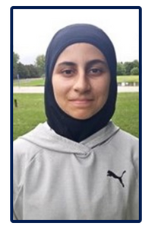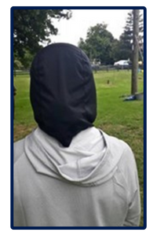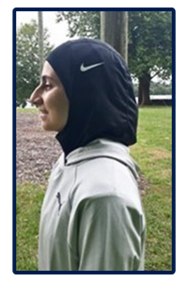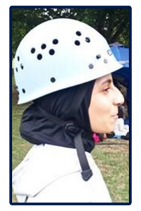
Figures 7, 8, and 9: Picture of a sport Hijab from the front, back, and side.
Figure 10: Picture of a helmet fitted correctly on a sport Hijab.
Source: First Step Outdoors.
- Give participants advance warning to tie their hair ‘small’ and at the nape of neck. Ideally, this should be part of pre-planning information to participants.
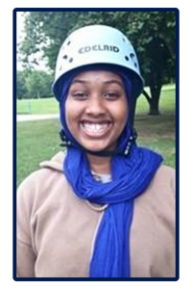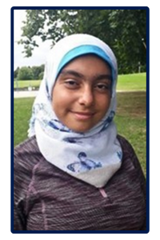
Figures 11, 12, and 13: Pictures demonstrating helmets on non-sport Hijabs.
Source: First Step Outdoors.

Wetsuits
- Consider modesty when participants are putting on and wearing a wetsuit. Because they are figure-hugging, wetsuits can be seen as revealing or immodest.
- Shorts could be worn over tight-fitting clothing.
- Have towels available at the end of sessions for modesty.

Clothing
- Clothing safety: With some discussion beforehand, you can provide clear information and explanation about clothing safety. Giving advance notice allows time to find solutions or alternative clothing options, which ensures both modesty and safe participation. It’s helpful to explain appropriate materials, as well as the risks of loose or heavy clothing.
- Highlight the risk of hyperthermia and hypothermia when wearing loose or baggy clothing. Explain why thermals are important, and how they help regulate body temperature. Describe why some materials, such as denim, are unsuitable to wear.
- Check in advance for any additional ‘flowing’ clothing (for example, long skirts or Abaya), which may create an issue for a particular activity.
  - For water activities like kayaking, excess material can be in the way if there is a capsize. Wet clothing becomes much heavier when wet, increasing the risk of submersion and potential drowning.
  - For height related activities like climbing and high ropes, can the participant safely fit the harness? Consider the risk of loose clothing getting trapped in equipment such as zip lines, belay devices and figure of eights.
- If long skirts are worn, can they be removed or tucked away without being a hazard?
- Consider what clothing you are asking the whole group to wear. If it is a Physical Education (PE) uniform, does it include an ‘adapted’ PE kit for young Muslim women? For swimming, allowing participants to choose their preferred swimwear, including options like the ‘burkini’ (full-covered swimsuit), supports inclusivity.

Examples of risk management strategies
Hazard | Harm / risk | Causal factors | Initial  risk level | Management strategy | Residual risk level
Hijab, scarves, or Niqab | Strangulation or entrapment  Potential head injury  Loss of modesty  Embarrassment | Loose Hijab, scarves, Niqab.  Incorrect fitting of helmets.  Hijab and hair placement.  Hijab may move off head when fitting PPE or due to weather conditions. | High | Tuck inside clothing or tie up tighter.  Ask girls to lower hair under Hijab.  Ensure the helmet fits securely over the Hijab and check carefully, as it may be hard to see.  Inform the participant that hijab might get moved.  Be aware of taking photos. | Medium
Flowing skirts, Abaya | Drowning  Entrapment  Incorrect fitting of harness | Leg entanglement in water activities.  Extra heavy clothing.  Extra layer creating ‘bunching’ under a harness. | Medium | Ask if a layer of clothing can be removed.  Instructor to be aware of risks (if worn).  Instructor to check correct fitting. | Low
Fasting during religious holy festivals | Low energy  Medical incident due to dehydration | Fasting for food and water, or both. | High | Pre-planning is important. Try to avoid fasting times.  Staff to be aware, considerate and flexible to group needs. | Medium

Leader Competence

The experience, knowledge and attributes needed by those working alongside the participants.
To ensure a leader’s cultural competency, ask them about their experience with Muslim and other ethnic communities. This includes strategies for cultural sensitivity, understanding of customs, and approaches to accommodating diversity. Leaders running an activity must have the respect of participants so their instruction, where reasonable, are followed. Building rapport encourages participants to share concerns or problems openly.
When assessing the cultural competency of an instructor or supervisor, consider the following points, along with corresponding reflective questions.

Ability to earn respect and rapport with the group
- Can you provide examples of how you establish respect and rapport with participants?
- How do you ensure participants trust you enough to seek help or report concerns?
- What strategies do you use to encourage participants to follow your instructions?

Relevant knowledge and skills
- Have you worked with Muslim groups in the past? If so, can you share your experience and how it went?
- Can you provide references or testimonials from your previous work with Muslim communities?
- How do you approach cultural openness and support participants in learning about different cultures? Are you open to respectful questions?

Sensitivity to religious and cultural practices
- Are you familiar with the religious and cultural practices specific to Muslim participants? For example, prayer times, dietary restrictions, and modesty requirements.
- How do you ensure activities and instructions respect these practices and create an inclusive environment?
- Can you share an example of a time when you accommodated specific religious or cultural needs during an activity?

Communication and conflict resolution skills
- How do you adapt your communication style to effectively engage with individuals from diverse cultural backgrounds?
- Can you provide an example of a conflict or misunderstanding related to cultural differences that you successfully resolved?
- How do you promote inclusive communication and ensure all participants feel heard and understood?
“Competent leaders are one of the mainstays of ensuring safety.”

Post-event
Review and seek feedback from participants, parents, teachers, and instructors.

Potential feedback questions
- What did you enjoy most about the event or camp?
- Did you feel your religious and cultural needs were respected and accommodated?
- Were there any challenges or concerns you encountered during the event or camp?
- How could the event or camp be improved to better meet your needs as a Muslimah participant?
- Did you feel included and valued as part of the group?

Parent feedback

To ask 1 – 2 weeks post-event
- What were your impressions of the event or camp in terms of its inclusivity and accommodation of religious and cultural needs?
- Did your child feel comfortable and respected throughout the event or camp?
- Were there any aspects of the event or camp that you believe could have been better addressed for Muslimah participants?
- How did your child’s experience align with your expectations as a parent?
- Would you recommend this event or camp to other Muslimah youth and their families?

Teacher feedback
- Did you notice any positive changes or growth after the event or camp?
- Were there any challenges or concerns related to Muslimah participation in the event or camp?
- Did you observe any instances where their religious and cultural needs were particularly well addressed or any areas for improvement?
- How do you think the experience at the event or camp affected participants’ overall development and learning?
- Would you recommend similar events or camps to other Muslimah students?

Instructor feedback
- How did you approach accommodating the religious and cultural needs of Muslimah participants?
- Were there any specific strategies or activities that you found effective in engaging and supporting their participation?
- Did you face any challenges or difficulties in ensuring inclusivity for Muslimah participants. If so, how did you address them?
- How would you evaluate the overall success of the event or camp in terms of inclusivity and religious and cultural accommodation?
- Are there any recommendations or suggestions you have for future events or camps involving Muslimah participants?
Record and track this feedback for valuable insights into the experiences of Muslim women and girls. This will help you to identify areas for improvement in future events or camps to better meet the needs of participants.

Further support
Find more information, including specialist websites and industry bodies.
- Halal Guide for New Zealand (Tourism New Zealand)
- Prayer times (the Federation of Islamic Associations of New Zealand)
- Sport Hijab (Adidas New Zealand)
- Muslimah participants in the outdoors (First Step Outdoors / Sport NZ)

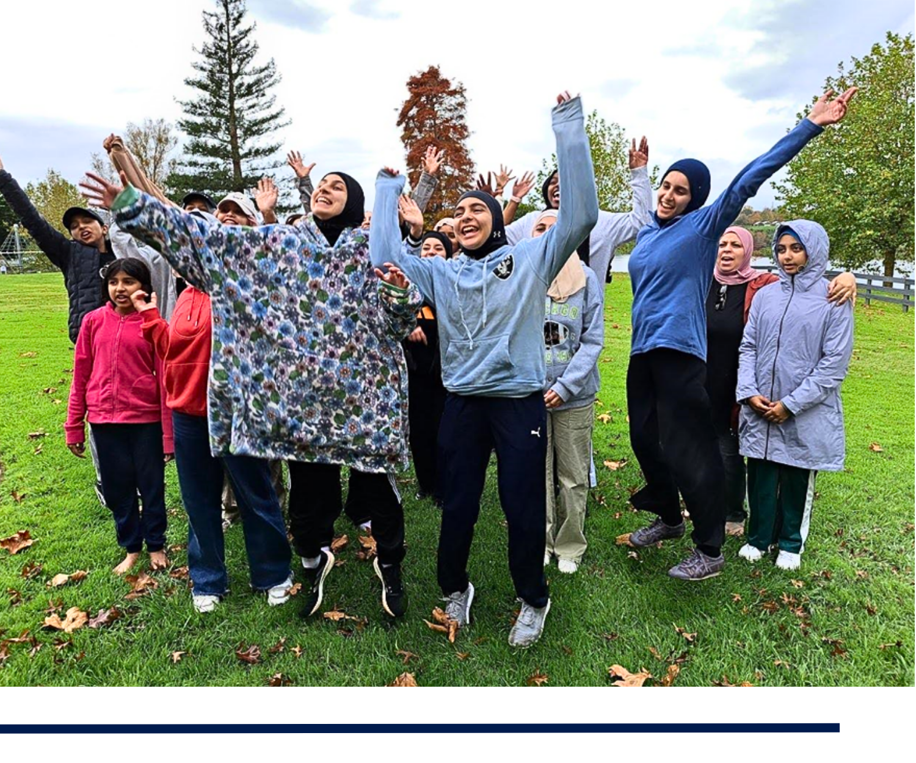

Glossary of terms
- Muslimah: A term used to refer to a Muslim woman or girl.
- Qur’an: The holy book of Islam considered the word of God as revealed to the Prophet Muhammad.
- Hijab: A headscarf or covering worn by Muslim women in public as a symbol of modesty and submission to God.
- Niqab: A face veil worn by some Muslim women, covering the hair and face except for the eyes.
- Abaya: A long, flowing garment that covers the whole body except the head, feet, and hands, often worn with the Hijab or Niqab.
- Burqa: A full body covering worn by some Muslim women, which covers the body from head to toe.
- Salah: The Islamic practice of ritual prayer performed five times a day.
- Fajr: The first of the five daily prayers, observed at dawn.
- Dhuhr: The second of the five daily prayers, observed at midday.
- Asr: The third of the five daily prayers, observed in the afternoon.
- Maghrib: The fourth of the five daily prayers, observed at sunset.
- Isha: The fifth and final of the five daily prayers, observed at night.
- Ramadan: The ninth month of the Islamic lunar calendar, observed by Muslims through fasting, prayer, and reflection.
- Eid: A festival or celebration in Islam, marking the end of fasting (Eid al-Fitr) or the conclusion of the Hajj pilgrimage (Eid al-Adha).
- Halal: Refers to what is permissible or lawful in Islamic law, especially in terms of food, which must be prepared in a certain way to be considered halal.
- FIANZ: The Federation of Islamic Associations of New Zealand, which provides services like prayer times and information for the Muslim community in New Zealand.
- Eid al-Fitr: The festival that marks the end of Ramadan, celebrated with feasts and prayers.
- Eid al-Adha: The festival commemorating the willingness of Prophet Ibrahim to sacrifice his son in obedience to God, observed with prayers and feasts.

